LAB - 9

|  |  |
| --- | --- |
| Name | Keval D Gandevia |
| Roll Number | CE046 |
| ID | 19CEUEG017 |
| Subject | Big Data Analytics |

**Aim:** CRUD operations and more using Hive query language.

* 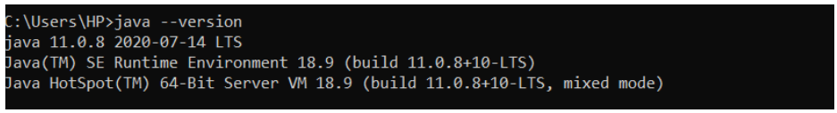**Checking the java version:**
* **Checking the Hadoop version:**

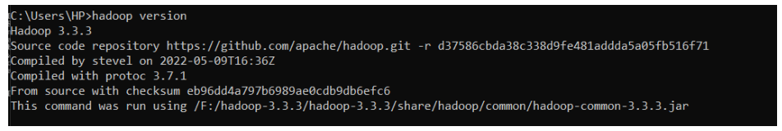

* 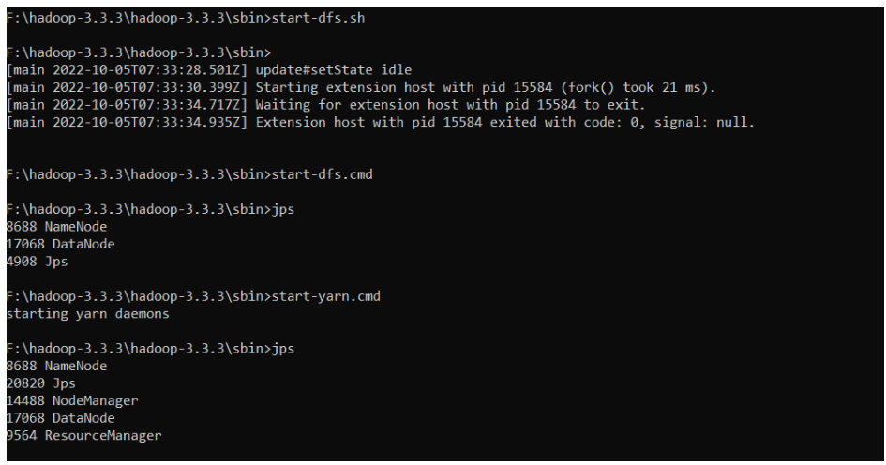**Starting the Hadoop server:**
* 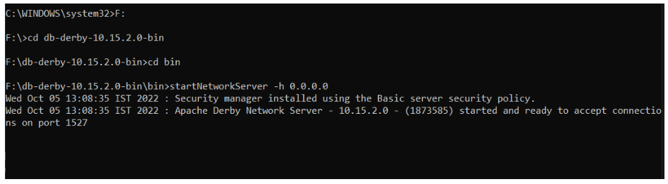**Starting the network server for hive:**
* 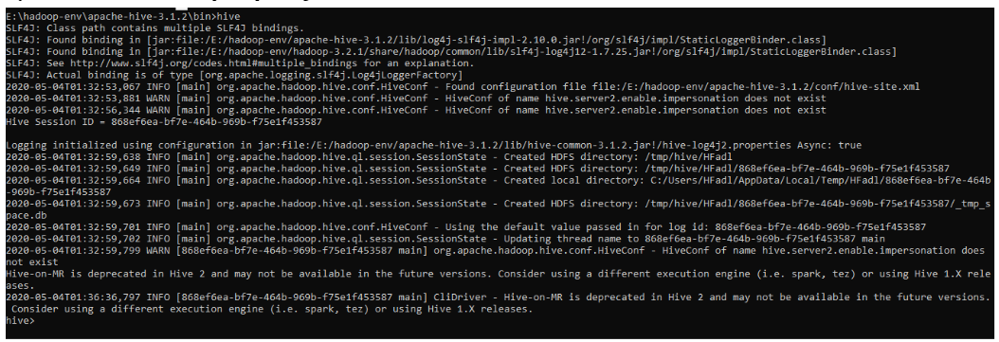**Ensuring that hive is properly installed or not:**

**CRUD operations in Hive.**

* 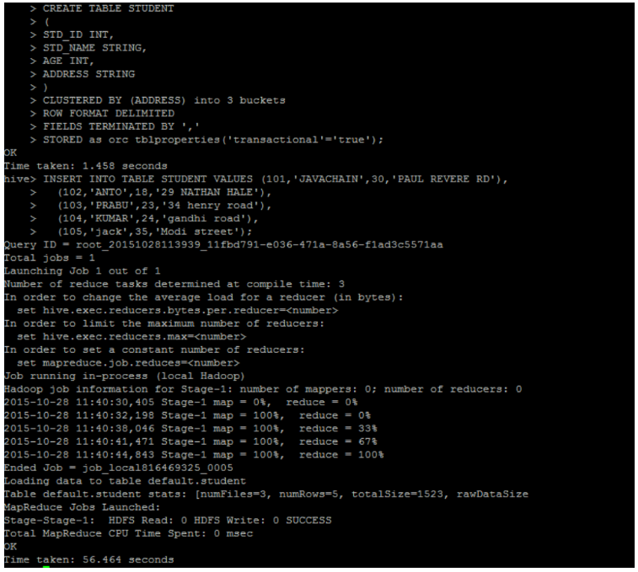**Creating table:**
* **Update operation:**

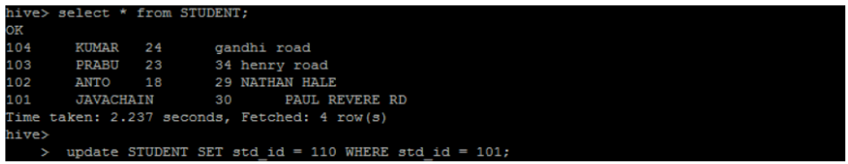

* **Verifying the entries after update operation:**

